美国伊利诺伊大学芝加哥分校（UIC）机械系主任讲座
时间：5月14日下午13:30-15:00
地点：汽车学院A311

UIC与同济机械、汽车、轨交等有3+1+1项目合作。
欢迎大家积极参加并提问。

报告题目：High-fidelity Simulation of Supersonic Combustor

Farzad Mashayek
Computational Multiphase Transport Laboratory (http://cmtl.uic.edu)
Department of Mechanical & Industrial Engineering
University of Illinois at Chicago
Chicago, IL 60607

ABSTRACT

Supersonic combustion holds a great promise to revolutionize the future aviation. While this has reinvigorated the interest in this area, many challenges are foreseen in achieving this goal. The focus of this talk is on large-eddy simulation (LES) of high-speed turbulent reacting flows. Several innovative methods have been implemented to develop advanced LES software based on a “high-order spectral element method on unstructured grid” that has been developed by our research group within the last two decades. The modeling of turbulent combustion interaction is via the accurate, probability density function-based “filtered mass density function (FMDF)” method in conjunction with a Monte-Carlo solver developed specifically for our high-order flow solver. Shock discontinuities are captured using an “entropy viscosity” approach that stabilizes the solution on a coarse grid by adding artificial viscosity. Several test cases, including a ramp-cavity combustor will be presented.

Biographical Sketch:
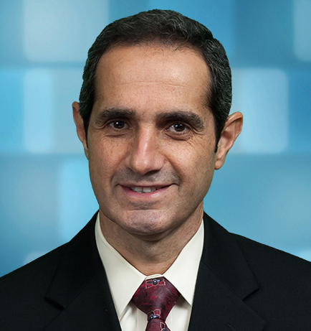
Farzad Mashayek received a Ph.D. degree in Mechanical Engineering from the State University of New York at Buffalo in 1994. He is currently Head of the Department of Mechanical and Industrial Engineering at the University of Illinois at Chicago. Mashayek’s research interests are in the areas of turbulent combustion, plasma, electrostatic atomization and solid ion batteries. He is a Fellow of ASME and an Associate Fellow of AIAA. Mashayek has received the CAREER award form the National Science Foundation and the Young Investigator award from the U.S. Office of Naval Research.

